Type 1 Driver - JDBC-ODBC bridge
Schematic of the JDBC-ODBC bridge
The JDBC type1 driver, also known as the JDBC-ODBC bridge, is a database driver implementation that employs the ODBC driver to connect to the database. The driver converts JDBC method calls into ODBC function calls.
The driver is platform-dependent as it makes use of ODBC which in turn depends on native libraries of the underlying operating system the JVM is running upon. Also, use of this driver leads to other installation dependencies; for example, ODBC must be installed on the computer having the driver and the database must support an ODBC driver. The use of this driver is discouraged if the alternative of a pure-Java driver is available.
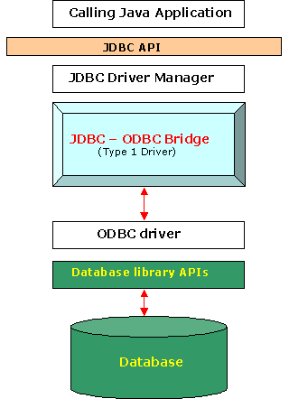

Functions
- Translates query obtained by JDBC into corresponding ODBC query, which is then handled by the ODBC driver.
- Sun provides a JDBC-ODBC Bridge driver. sun.jdbc.odbc.JdbcOdbcDriver.
- Client -> JDBC Driver -> ODBC Driver -> Database

Advantages
- Easily available.

Disadvantages
- Performance overhead since the calls have to go through the jdbc Overhead bridge to the ODBC driver, then to the native db connectivity interface (thus may be slower than other types of drivers).
- The ODBC driver needs to be installed on the client machine.

Type 2 Driver - Native-API Driver Or also called Partial Java Driver
The JDBC type 2 driver, also known as the Native-API driver, is a database driver implementation that uses the client-side libraries of the database. The driver converts JDBC method calls into native calls of the database API.

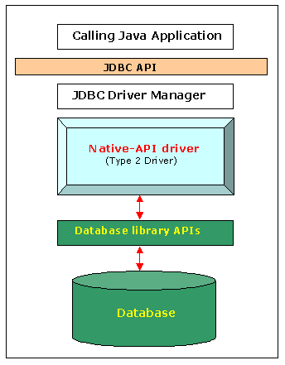
Oracle's OCI (Oracle Call Interface) client-side driver is an example of a Type 2 driver.
Advantages
- As there is no implementation of jdbc-odbc bridge, its considerably faster than a type-1 driver.
Disadvantages
- The vendor client library needs to be installed on the client machine.
- This driver is platform dependent

Type 3 Driver - Network-Protocol Driver
The JDBC type 3 driver, also known as the Pure Java Driver for Database Middleware, is a database driver implementation which makes use of a middle tier between the calling program and the database. The middle-tier (application server) converts JDBC calls directly or indirectly into the vendor-specific database protocol.
This differs from the type 4 driver in that the protocol conversion logic resides not at the client, but in the middle-tier. Like type 4 drivers, the type 3 driver is written entirely in Java. The same driver can be used for multiple databases. It depends on the number of databases the middleware has been configured to support. The type 3 driver is platform-independent as the platform-related differences are taken care of by the middleware.
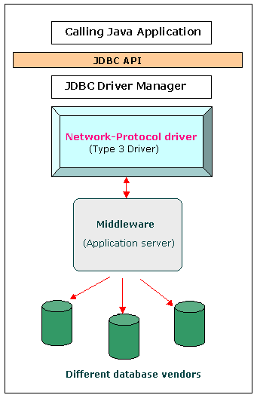

Functions
- Follows a three tier communication approach.
- Can interface to multiple databases - Not vendor specific.
- The JDBC Client driver written in java, communicates with a middleware-net-server using a database independent protocol, and then this net server translates this request into database commands for that database.
- Thus the client to middleware communication is database independent.
- Client -> JDBC -> Network-protocol driver -> Middleware-Net Server -> Any Database,...

Advantages
- Since the communication between client and the middleware server is database independent, there is no need for the vendor db library on the client machine. Also the client to middleware need not be changed for a new database.
- The Middleware Server (which can be a full fledged J2EE Application server) can provide typical middleware services like caching (connections, query results, and so on), load balancing, logging etc.

Disadvantages
- Requires database-specific coding to be done in the middle tier.
- An extra layer added may result in a time-bottleneck. But typically this is overcome by providing efficient middleware services.

Type 4 Driver - Native-Protocol Driver
The JDBC type 4 driver, also known as the Direct to Database Pure Java Driver, is a database driver implementation that converts JDBC calls directly into a vendor-specific database protocol. Therefore it is called a THIN driver.
Written completely in Java, type 4 drivers are thus platform independent. This provides better performance than the type 1 and type 2 drivers as it does not have the overhead of conversion of calls into ODBC or database API calls. Unlike the type 3 drivers, it does not need associated software to work.
As the database protocol is vendor-specific, the JDBC client requires separate drivers, usually vendor-supplied, to connect to different types of databases.
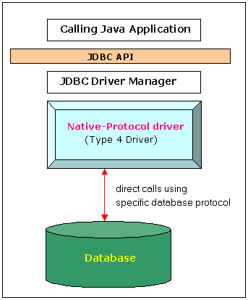

Functions
- Type 4 drivers, coded entirely in Java, communicate directly with a vendor's database, usually through socket connections. No translation or middleware layers are required, improving performance.
- The driver converts JDBC calls into the vendor-specific database protocol so that client applications can communicate directly with the database server.
- Completely implemented in Java to achieve platform independence.
- This type includes (for example) the widely-used Oracle thin driver - oracle.jdbc.driver.OracleDriver which connects using a format configuration of jdbc:oracle:thin:@URL
- Client -> JDBC -> Native-protocol JDBC Driver -> database server.

Advantages
- These drivers don't translate the requests into an intermediary format (such as ODBC), nor do they need a middleware layer to service requests. This can enhance performance considerably.

Disadvantages
- Drivers are database dependent, as different database vendors use different (and usually proprietary) network protocols.

